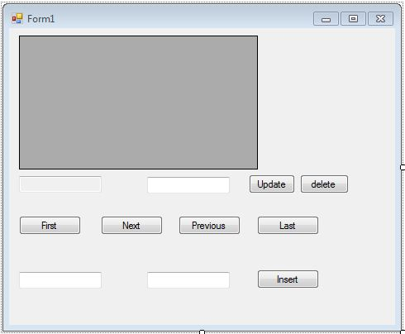

Imports System.Data.SqlClient

Public Class Form1

Private connectionString As String = "Data Source=.\SQLEXPRESS;AttachDbFilename='C:\Users\ibsar1\Documents\Visual Studio 2010\Projects\grid\grid\testdb.mdf';Integrated Security=True;Connect Timeout=30;User Instance=True"

Dim ds As New DataSet()

Dim i As Integer

Private Sub Form1_Load(ByVal sender As System.Object, ByVal e As System.EventArgs) Handles MyBase.Load

fillData()

End Sub

Private Sub btnFirst_Click(ByVal sender As System.Object, ByVal e As System.EventArgs) Handles btnFirst.Click

If (ds.Tables(0).Rows.Count > 0) Then

i = 0

txtID.Text = ds.Tables(0).Rows(i)("id").ToString()

txtName.Text = ds.Tables(0).Rows(i)("name").ToString()

End If

End Sub

Private Sub btnNext_Click(ByVal sender As System.Object, ByVal e As System.EventArgs) Handles btnNext.Click

If (i < ds.Tables(0).Rows.Count - 1) Then

i += 1

txtID.Text = ds.Tables(0).Rows(i)("id").ToString()

txtName.Text = ds.Tables(0).Rows(i)("name").ToString()

Else

MsgBox("You are on last record")

End If

End Sub

Private Sub btnPrevious_Click(ByVal sender As System.Object, ByVal e As System.EventArgs) Handles btnPrevious.Click

If (i = ds.Tables(0).Rows.Count - 1 Or i <> 0) Then

i -= 1

txtID.Text = ds.Tables(0).Rows(i)("id").ToString()

txtName.Text = ds.Tables(0).Rows(i)("name").ToString()

Else

MsgBox("You are on first record")

End If

End Sub

Private Sub btnLast_Click(ByVal sender As System.Object, ByVal e As System.EventArgs) Handles btnLast.Click

i = ds.Tables(0).Rows.Count - 1

txtID.Text = ds.Tables(0).Rows(i)("id").ToString()

txtName.Text = ds.Tables(0).Rows(i)("name").ToString()

End Sub

Private Sub btndel_Click(ByVal sender As System.Object, ByVal e As System.EventArgs) Handles btndel.Click

If MessageBox.Show("Do you really want to Delete this Record?", "Delete", MessageBoxButtons.YesNo, MessageBoxIcon.Warning) = DialogResult.Yes Then

deldata()

Else

MsgBox("Operation Cancelled")

End If

End Sub

Private Sub btnInsert_Click(ByVal sender As System.Object, ByVal e As System.EventArgs) Handles btnInsert.Click

insertRec()

End Sub

Private Sub btnUpdate_Click(ByVal sender As System.Object, ByVal e As System.EventArgs) Handles btnUpdate.Click

Dim Query As String

Dim con As SqlConnection = New SqlConnection(connectionString)

con.Open()

Query = "UPDATE table1 SET name ='" + txtName.Text + "'" + " WHERE id = " + txtID.Text

Dim cmd As SqlCommand = New SqlCommand(Query, con)

MsgBox(Query)

Dim i As Integer = cmd.ExecuteNonQuery()

If (i > 0) Then

MsgBox("Record is Successfully Updated")

Else

MsgBox("Record is not Updated")

End If

con.Close()

DataGridView1.DataSource = Nothing

ds.Clear()

fillData()

End Sub

Private Sub insertRec()

Dim Query As String

Dim con As SqlConnection = New SqlConnection(connectionString)

con.Open()

Dim id As Integer = CInt(txtinsId.Text)

Dim name As String = CStr(txtinsName.Text)

Query = "Insert into table1(id,name) values (" & id & ",' " & name & " ')"

Dim cmd As SqlCommand = New SqlCommand(Query, con)

MsgBox(Query)

Dim i As Integer = cmd.ExecuteNonQuery()

If (i > 0) Then

MsgBox("Record is Successfully Updated")

Else

MsgBox("Record is not Updated")

End If

con.Close()

DataGridView1.DataSource = Nothing

ds.Clear()

fillData()

End Sub

Private Sub fillData()

Dim connection As New SqlClient.SqlConnection(connectionString)

Dim Sql As String = "Select * from table1"

Dim dataadapter As New SqlDataAdapter(Sql, connection)

connection.Open()

dataadapter.Fill(ds, "table1")

connection.Close()

DataGridView1.DataSource = ds

DataGridView1.DataMember = "table1"

connection.Close()

End Sub

Private Sub deldata()

Dim cmd As New SqlCommand

Dim con As SqlConnection = New SqlConnection(connectionString)

con.Open()

cmd.Connection = con

cmd.CommandText = "Delete from table1 where id = " & CInt(txtID.Text)

cmd.ExecuteNonQuery()

MessageBox.Show("record deleted...", "Delete Records")

con.Close()

DataGridView1.DataSource = Nothing

ds.Clear()

fillData()

End Sub

Private Sub DataGridView1_CellContentClick(ByVal sender As System.Object, ByVal e As System.Windows.Forms.DataGridViewCellEventArgs) Handles DataGridView1.CellContentClick

End Sub

End Class